**Create a file named student with fields (roll no, student name, marks). Fields are separated by colon “:” .**

1. **Display the content of file.**

**cat student.dat**

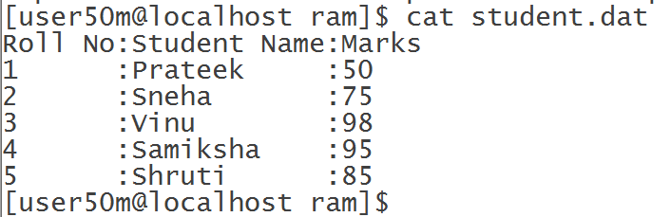

**2) Search for name of your friend.**

**grep -i samiksha student.dat**

**cut -d ":" -f 2 student.dat | grep -i vinu**

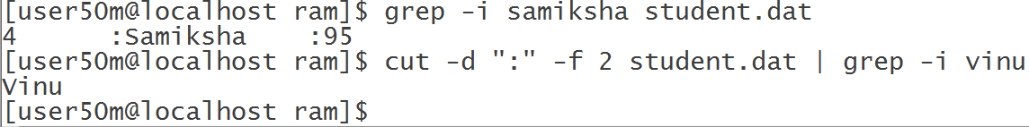

1. **Delete the given file.**

**rm student.dat**

1. **Create the link for the given file.**

**ln -s student.dat /home/user50m/**

**go to home directory and execute below command.**

**ll**

